How to place an order ORDER DESK
- Login to the website at www.fidelitydesktop.com
- Click PLACE AN ORDER
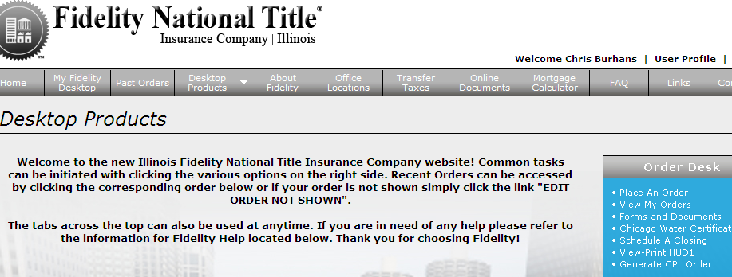

- Fill out the information for each step, BOLD fields are required
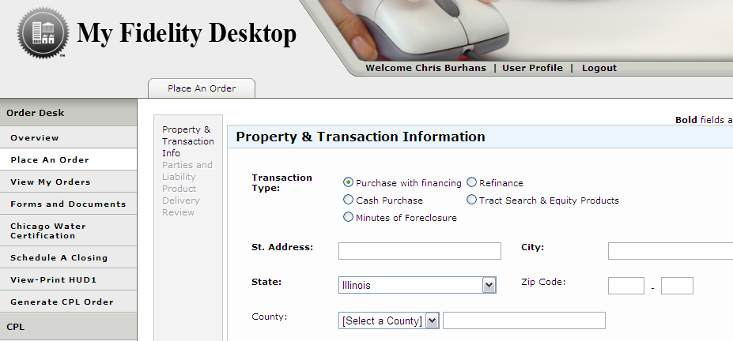
These are the order screens that will be displayed

- One the PRODUCT DELIVERY screen, you can add email addresses that will also get correspondence regarding that order. Simply click ADD EMAIL to add anyone not list, for anyone who is listed move their name to the right hand side to copy them for this order. The users email is copied by default

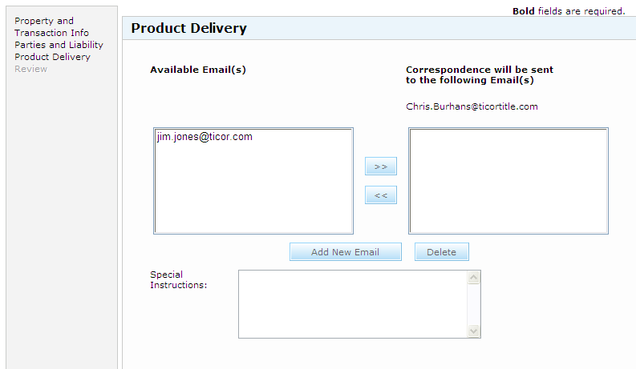

- You will receive a message saying “YOUR ORDER DESK ORDER has been submitted successfully” after submitting your order.

- The user will receive emails indicating the order number, and when the commitment application is uploaded. Upon receiving these emails, the order will be complete. To view the order click VIEW MY ORDERS after logging in.

- The order will then be displayed and the commitment can be view by clicking the ICON.

